INTEGRATED INFORMATION PLATFORM FOR INDIAN UNIVERSITIES
by

TALAGANA BHARATH KUMAR 322506402411
TANIKELLA PRANAV 322506402416
DAVIS JOHAN 322506402417
GURUGUBELLI SAI VAMSI 322506402364

In the partial fulfillment of the requirements for the award of the degree of
BACHELOR OF TECHNOLOGY
In
COMPUTER SCIENCE AND SYSTEMS ENGINEERING
Under the esteemed guidance of

Prof. K.S.S.SOUJANYA KUMARI

Department of Computer Science and

Systems Engineering

ANDHRA UNIVERSITY COLLEGE OF ENGINEERING (A)
ANDHRA UNIVERSITY
DEPARTMENT OF COMPUTER SCIENCE AND SYSTEMS ENGINEERING
ANDHRA UNIVERSITY COLLEGE OF ENGINEERING (A)
ANDHRA UNIVERSITY
VISAKHAPATNAM


CERTIFICATE

This is to certify that the project report entitled, “INTEGRATED INFORMATION PLATFORM FOR INDIAN UNIVERSITIES” is the Bonafide work carried out by TALAGANA BHARATH KUMAR with Regd.No:322506402411, TANIKELLA PRANAV with Regd.No:322506402416, DAVIS JOHAN with Regd.No:322506402417 and GURUGUBELLI SAI VAMSI with Regd.No:322506402364 students of B.Tech in AU COLLEGE OF ENGINEERING(A), ANDHRA UNIVERSITY, VISAKHAPATNAM, during the year 2022-2026, in partial fulfillment of the requirements for the award of degree of BACHELOR OF TECHNOLOGY

Prof. K.S.S.SOUJANYA KUMARI Prof. V.VALLI KUMARI
Project Guide Head of the Department

ACKNOWLEDGEMENT

I would like to show my greatest appreciation To Prof. K.S.S.SOUJANYA KUMARI enough for his tremendous support and help without her encouragement and guidance this project Would not have materialized.
I would like to thank Prof. V.VALLI KUMARI, Head of the Department, computer science and systems engineering, Andhra University College of Engineering(A), for her encouragement and valuable guidelines in bringing shape to the dissertation.
I wish to express thanks to Prof. M. SHASHI, Principal, Andhra University College of Engineering (A), for helping me in completing the project work on time.

I would like to thank teaching staff and non-teaching staff members of the department of computer science and systems engineering, Andhra University College of Engineering (A), Visakhapatnam, for their constant support in successful completion of my study.
Finally, I express my indebtedness to my beloved parents and friends without whose blessings and encouragement I would not have completed my work fruitfully.

DECLARATION

I declare that the project report entitled “INTEGRATED INFORMATION PLATFORM FOR INDIAN UNIVERSITIES” has been done by me in partial fulfillment of requirement for the award of degree of “Bachelor of Technology”, during the academic year 2022 - 2026 under the guidance of “Prof.K.S.S.SOUJANYA KUMARI”, department of computer science and systems engineering, AU College of Engineering(A), Andhra University, Visakhapatnam. I, here by declare that this project work has not been submitted to any other universities/institutions for the award of any degree.

PLACE: VISAKHAPATNAM
DATE:

TALAGANA BHARAT KUMAR
(322506402411)

TANIKELLA PRANAV
(322506402416)

DAVIS JOHAN
(322506402417)

GURUGUBELLI SAI VAMSI
(322506402364)

ABSTRACT

A full-stack University Recommendation and Comparison Platform designed to help students make informed admission decisions based on exam rank, institution quality, fees, placements, and branch-wise cutoff trends. The system integrates a structured data pipeline, secure authentication, and an analytics-driven interface to deliver a scalable decision-support solution.
The data layer is initialized using a curated JSON dataset supported by spreadsheets containing branch cutoff information. An automated update script ensures integration of the latest cutoff data, while a seeding script populates the MongoDB database and estimates missing values such as placement rates and tuition fees using fallback logic based on ranking tiers and institution type. This approach ensures data completeness and consistency even with partial inputs.
The backend is built with Node.js and Express, providing RESTful APIs for authentication, user management, and university data retrieval. Security is implemented using JWT-based authentication and password hashing. The frontend is a React Single Page Application (SPA) utilizing Context API for global state management through AuthContext, UniversityContext, and SavedContext.
The platform supports a complete user workflow: students can input their rank, explore suitable universities, apply filters and sorting, view detailed metrics, compare institutions, and analyze insights through interactive dashboards. Authenticated users can also maintain a personalized shortlist.
The system follows a decoupled architecture, with the frontend deployed on platforms like Vercel or GitHub Pages and the backend hosted on services such as Render, connected to MongoDB Atlas. Overall, the project demonstrates an effective use of modern web technologies to address real-world challenges in educational decision-making, emphasizing usability, scalability, and data reliability.

TABLE OF CONTENTS
Chapter No. | TITLE | Page no.
 | Abstract | I
 | Table of Contents | II
1. Introduction |  | 1
1.1 Problem Statement |  | 3
1.2 Objective of the project |  | 4
1.3 Purpose of the project |  | 5
1.4 Scope of the project |  | 6
1.5 Benefits of the project |  | 6

2 Review Of Literature 8
- Software Requirement Analysis 11
  - Domain Analysis 11
  - Requirement Analysis 13
- System analysis Design 21
  - System Design 21
  - ER diagram 26
  - UML diagrams 28
    - Class diagram 29
    - Use- case diagram 31
    - Sequence diagram 33
    - Activity diagram 35
    - State chart diagram 36
    - Object diagram 38
    - Collaboration diagram 40
    - Component diagram 41
    - Deployment diagram 42
- Implementation and Testing 44
  - Implementation of Codes 44
  - Functional Testing 47
  - Non- functional testing 48
  - Error Handling testing 49
  - Integration testing 49
  - Unit testing 50
- Data Visualization 53
- Result 60
- Conclusion and Future Enhancement 60
  - Conclusion 63
  - Future Enhancement 63
- References 65

CHAPTER 1: INTRODUCTION

Introduction

Choosing the right university is one of the most important decisions in a student’s academic journey. For many students, especially those applying through competitive entrance examinations, this decision is not simply about selecting a well-known institution—it is a complex evaluation process involving rank eligibility, tuition fees, placement opportunities, accreditation, branch availability, location preferences, and long-term career outcomes. In countries like India, where admissions are often driven by national and state-level entrance examinations, the challenge becomes even greater because of the sheer volume of institutions and the dynamic nature of cutoff trends. Students and parents are expected to compare hundreds of colleges, understand historical rank cutoffs, estimate admission chances, and align all of this with financial and personal constraints. This process is often time-consuming, confusing, and heavily dependent on fragmented information sources.
Most students today rely on a combination of unofficial websites, coaching institute lists, social media discussions, and peer recommendations to make their choices. While these sources can be helpful, they are rarely structured in a way that supports objective and data-driven decision-making. Information is often outdated, inconsistent across platforms, or incomplete for specific branches and categories. In many cases, students are forced to manually compare colleges by opening multiple tabs, checking old PDF documents, and making rough assumptions about admission probability. This not only increases the cognitive load on students but also creates a high risk of poor decision-making due to misinformation or incomplete analysis.
To address this gap, the University Recommendation and Comparison Platform was designed as a full-stack web application that simplifies the university selection process by combining verified data, intelligent filtering, and interactive analytics into a single unified interface. The platform enables students to input their exam type and rank, instantly discover eligible universities, and compare institutions across multiple criteria such as placements, fees, accreditation, and branch-specific cutoffs. Rather than presenting static lists, the system is built to support personalized discovery and informed decision-making through dynamic filters, ranking-based matching logic, and visual insights.
At its core, the platform aims to answer a simple but critical question:
“Given my rank, budget, and preferences, which universities are the best options for me?”
This project is not just a directory of universities; it is a decision-support system. It integrates backend APIs, secure authentication, a structured database, and a modern React frontend to create a seamless user experience from initial search to final shortlist. The system architecture is designed to be modular and scalable, making it suitable not only as an academic project but also as a production-ready foundation that can be extended in the future with recommendation algorithms, predictive analytics, and personalized counseling features.

Background and Need for the System
The higher education landscape has grown rapidly in the past decade. New universities, private institutions, autonomous colleges, and specialized technical institutes have emerged across states, offering a wide range of programs in engineering, science, management, and other disciplines. While this expansion has increased opportunities for students, it has also made the admission process significantly more complex.
Students preparing for entrance exams such as JEE, EAMCET, KCET, MHT-CET, and other state or national tests often receive a rank and then face a difficult challenge: understanding which colleges they can realistically get into. Admission to a particular branch in a university depends not only on the overall rank but also on category, quota, seat availability, and yearly cutoff fluctuations. Even if a student knows their rank, they may not know whether it is “good enough” for Computer Science in one university but not for Electronics in another. They may also struggle to evaluate whether a lower-ranked college with better placements is a smarter choice than a higher-ranked institution with expensive fees.
Traditional counseling support is usually available only for a short period and often focuses on broad guidance rather than personalized analysis. Students from rural or underserved regions may have limited access to mentors, making them even more dependent on online resources. In such situations, a platform that centralizes data and enables rank-based filtering can make a substantial difference.
The need for this system arises from three major challenges in the current admission ecosystem:
- Information Fragmentation – Data is scattered across official websites, PDF brochures, spreadsheets, and educational portals, with no standard format.
- Lack of Personalization – Most resources provide general lists of “top colleges” but do not account for individual rank, branch preference, or budget.
- No Comparative Intelligence – Students are rarely given tools to compare universities side by side using multiple metrics such as NAAC grade, placements, and fees.
This project addresses all three challenges by creating a centralized and interactive platform where students can discover, compare, and analyze universities based on their own profile and goals.

Project Vision and Objectives
The vision of this project is to build a student-centric platform that transforms the university search process from guesswork into a structured, data-driven experience. Instead of relying on assumptions or generic rankings, students should be able to make decisions based on transparent and relevant data.
The primary objectives of the project are:
- To provide a rank-based university recommendation system that helps students identify eligible institutions quickly.
- To support advanced filtering and sorting, enabling users to narrow down options by state, fee range, accreditation, exam type, and placement records.
- To offer detailed university profiles with branch-wise cutoff information, official website links, and key performance indicators.
- To enable side-by-side comparison of universities on multiple dimensions.
- To provide visual analytics dashboards that summarize trends and patterns in the dataset.
- To implement secure user authentication so students can create accounts and maintain personalized shortlists.
- To ensure the system is scalable and maintainable, with a clean separation between frontend, backend, and database layers.
These objectives are aligned with real-world user needs and also reflect modern software engineering practices such as modular design, reusable components, and API-driven architecture.

Scope of the Project
The project is designed as a full-stack web application with three main layers: data management, backend services, and frontend user interface. The scope includes:
Data Collection and Preparation
The system uses a curated dataset stored in universities.json, enriched with branch-wise cutoff data from spreadsheet files. A custom script updates rank cutoffs and writes them into the JSON file. During database seeding, the system fills missing values using fallback estimation rules, ensuring that all universities have meaningful values for key metrics like placement percentage and fees.
Backend API Development
The backend is developed using Express and connects to MongoDB. It provides:
- Authentication endpoints for signup and login
- User profile endpoints protected by JWT verification
- University endpoints for listing all institutions and fetching details by ID
This API layer acts as the bridge between raw data and frontend presentation.
Frontend Development
The frontend is built with React and Vite, using Context API for global state management. It includes:
- Home page for rank and exam input
- Universities page with filters, sorting, and pagination
- University detail page with complete metrics
- Comparison page for side-by-side analysis
- Dashboard page with charts and insights
- Login, signup, and profile pages for authenticated users
Deployment and Production Readiness
The project supports decoupled deployment:
- Frontend can be hosted on GitHub Pages or Vercel
- Backend can be deployed on Render or Railway
- Database is hosted on MongoDB Atlas
This deployment model allows independent scaling and maintenance of frontend and backend services.

Significance of the Project
This project is significant for both academic and practical reasons.
From an academic perspective, it demonstrates the integration of multiple technologies and concepts:
- Data preprocessing and seeding
- REST API development
- Authentication and authorization
- State management in React
- Client-side filtering and pagination
- Data visualization using charts
- Deployment architecture for modern web applications
From a practical perspective, it solves a real problem faced by thousands of students every year. By providing a platform that is intuitive, fast, and data-rich, it can reduce confusion and improve the quality of admission decisions. The ability to compare universities based on personalized criteria makes the system more useful than static ranking lists.
The project also promotes digital inclusion by making educational guidance more accessible. Students who may not have access to expensive counseling services can use the platform to explore options independently.

Existing Systems and Their Limitations
Before building this platform, it is important to understand the limitations of existing systems:
- Official University Websites
These sites usually contain accurate information but are difficult to compare because each university uses a different format and structure.
- Counseling Portals
Many portals provide cutoff lists and rankings but often require paid subscriptions for advanced features. They may also lack transparency in ranking methodology.
- Coaching Institute Materials
Printed lists and PDFs are static and become outdated quickly. They do not support dynamic filtering or personalized recommendations.
- Social Media and Forums
Community discussions can provide insights but are subjective and not always reliable.
The proposed system improves on these by offering a single platform with structured data, real-time filtering, and objective comparison tools.

Technical Overview (High-Level)
The platform follows a modern full-stack architecture:
- Frontend: React SPA running on port 3000
- Backend: Express server running on port 5000
- Database: MongoDB collection universities
- Authentication: JWT-based login/signup
- State Management: Context API (AuthContext, UniversityContext, SavedContext)
This separation of concerns ensures maintainability and allows independent development of each layer. The frontend communicates with the backend through REST APIs, and the backend interacts with MongoDB for persistent storage.
The use of Context API avoids excessive prop drilling and provides a centralized way to manage session state, cached university data, and saved bookmarks.

User-Centric Design Approach
One of the key strengths of this project is its user-centric design. The platform is built around the actual workflow of a student:
- Enter rank and exam type
- View matching universities
- Apply filters and sort options
- Open detailed pages for shortlisted colleges
- Compare top choices
- Save favorites after login
- Use dashboard insights for broader understanding
This flow is intuitive and mirrors the way students naturally think during the admission process. The interface is designed to be clean, responsive, and easy to navigate, reducing friction and making the system accessible even to first-time users.

Challenges Addressed by the Project
During development, several practical challenges were addressed:
- Handling Missing Data:
Not all universities had complete placement or fee information. The seeding script uses fallback estimation to ensure completeness.
- Complex Filtering Logic:
The filtering system supports nested conditions (e.g., state-specific filters under “State CET”) and rank-based eligibility checks.
- Session Persistence:
AuthContext stores JWT in localStorage and restores user sessions automatically on page reload.
- Performance Optimization:
UniversityContext caches the university list to avoid repeated API calls, improving load times.
- Scalable UI Design:
Pagination and sorting ensure the interface remains responsive even with large datasets.
These challenges reflect real-world software engineering constraints and demonstrate the robustness of the implementation.

Future Enhancements
Although the current version is fully functional, the platform has significant scope for future improvements:
- Integration of machine learning models for personalized recommendations
- Real-time cutoff prediction based on historical trends
- Category- and quota-based admission logic
- Push notifications for counseling updates
- Admin dashboard for data management
- Export options (PDF reports, shortlist summaries)
- Mobile app version for wider accessibility
These enhancements can transform the project into a complete education guidance ecosystem.

Conclusion of the Introduction
The University Recommendation and Comparison Platform is a meaningful and technically rich solution to a real-world problem faced by students during the admission process. By combining structured data, intelligent filtering, secure authentication, and interactive analytics, the platform empowers users to make informed and confident decisions. It demonstrates how modern web technologies can be applied to educational guidance in a practical and scalable way.
This project is not only a strong academic submission but also a valuable product concept with real deployment potential. It showcases full-stack development skills, thoughtful system design, and a clear understanding of user needs—making it an excellent example of technology solving a socially relevant challenge.

Problem Statement
The process of selecting a suitable university after entrance examinations is a major challenge for students due to the lack of a centralized, reliable, and personalized decision-making system. Students are required to evaluate multiple factors such as entrance rank eligibility, branch-wise cutoff trends, tuition fees, placement opportunities, accreditation status, and geographic preferences. However, this information is usually scattered across different sources including official university websites, counseling PDFs, coaching institute documents, and third-party portals. As a result, students often struggle to make accurate comparisons and informed choices within the limited counseling timeline.
Existing systems and resources have several limitations. Most platforms provide generic lists of top colleges without considering the student’s individual rank, preferred exam type, budget, or branch interest. Official websites may contain authentic data, but they are difficult to compare because each institution presents information in a different format. Coaching materials and static cutoff documents quickly become outdated and do not support dynamic filtering. In addition, many available portals lack transparency in how they rank colleges, and some restrict useful features behind paid subscriptions. This creates a gap where students, especially those from rural or underserved backgrounds, are forced to rely on guesswork, peer opinions, or incomplete information.
Another key issue is the absence of an integrated comparison mechanism. Students often manually open multiple tabs and try to compare colleges by memory or handwritten notes, which is inefficient and error-prone. There is no standard system that allows them to compare universities side by side based on measurable indicators such as NAAC grade, placement percentage, annual fees, and branch-specific cutoff ranks. This leads to confusion and increases the probability of making poor admission decisions that may affect their long-term academic and career outcomes.
Furthermore, the current admission guidance process does not provide sufficient support for personalized exploration. A student with a specific rank may want to know which universities are realistically attainable, but available systems rarely provide rank-based filtering combined with advanced search criteria. Students are also unable to visualize trends, such as how placements vary by state or how fees relate to accreditation and ranking. Without such analytical insights, decision-making remains superficial and reactive rather than data-driven.
To address these challenges, there is a clear need for a full-stack, user-friendly, and scalable platform that centralizes university data and supports intelligent decision-making. The proposed solution should allow students to enter their exam type and rank, instantly identify eligible universities, apply advanced filters, compare shortlisted institutions, and access detailed profiles with branch-wise cutoffs, fees, and placement information. It should also provide secure user authentication so that students can save their preferences and revisit their choices. In addition, the system should include visual dashboards to present high-level insights and trends that help students understand the broader admission landscape.
Therefore, the problem this project aims to solve is: how to design and implement an integrated University Recommendation and Comparison Platform that reduces information fragmentation, supports personalized rank-based filtering, and enables students to make informed, data-driven admission decisions efficiently and confidently.

Objectives of the Project
The primary objective of this project is to design and develop a University Recommendation and Comparison Platform that helps students make informed admission decisions based on their entrance exam rank, preferences, and key institutional parameters. The system is intended to solve the common problem of information fragmentation and decision uncertainty by providing a centralized, data-driven, and user-friendly web application. Instead of manually searching through multiple websites and documents, students can use a single platform to discover, filter, compare, and shortlist universities in a structured and efficient manner.
One of the core objectives is to build a rank-based recommendation mechanism that allows students to input their exam type and rank, and then receive a list of universities that are realistically attainable. This objective ensures that the platform is personalized and practical, rather than presenting generic college lists. The recommendation logic must be capable of evaluating branch-wise cutoff trends and determining eligibility dynamically, thereby reducing confusion and helping students focus on relevant options only.
Another important objective is to implement a comprehensive filtering and search system that enables users to refine university results based on multiple criteria such as state, fee range, accreditation grade, institution type, and placement percentage. This objective is crucial because students often have unique constraints, including budget limitations and location preferences. By supporting advanced filters and sorting options, the platform allows users to customize their search and identify universities that align with both academic and financial goals.
The project also aims to provide a detailed university profile module where users can access complete information about a selected institution. This includes branch-wise cutoff ranks, placement statistics, annual fees, accreditation details, and official website links. The objective here is to ensure transparency and completeness of information, so students can evaluate each university on objective parameters instead of relying on assumptions or incomplete data.
A key objective is to develop a side-by-side comparison feature that allows students to compare up to three universities simultaneously across important metrics. This functionality is designed to simplify decision-making by presenting comparable data in a single table format, helping users quickly identify strengths and weaknesses of each option. In addition, the project seeks to include an analytics dashboard with visual charts to provide high-level insights, such as state-wise distribution of universities, NAAC grade spread, and relationships between fees and placement outcomes.
From a technical perspective, the project aims to implement a secure and scalable full-stack architecture using React for the frontend, Express for the backend, and MongoDB for the database. The system must support JWT-based authentication for user signup and login, ensuring that users can securely save and manage their shortlisted universities. It should also use efficient state management through React Context to improve performance and maintain a smooth user experience.
Finally, the project aims to be deployment-ready and extensible, with a decoupled architecture that allows the frontend and backend to be hosted independently on modern cloud platforms. This objective ensures that the platform can be scaled in the future with additional features such as predictive analytics, category-based cutoff support, and AI-driven recommendations.

Purpose of the Project
The purpose of this project is to develop a centralized and intelligent University Recommendation and Comparison Platform that simplifies the complex process of selecting a suitable university after entrance examinations. Every year, students face significant difficulty in deciding where to apply because admission decisions depend on multiple factors such as rank eligibility, branch-wise cutoffs, tuition fees, placement opportunities, accreditation, and location preferences. The available information is often scattered, inconsistent, and difficult to compare. As a result, many students make decisions based on incomplete knowledge, assumptions, or external influence rather than objective analysis. This project is intended to solve that problem by providing a single, reliable platform where students can explore and evaluate universities in a structured and personalized way.
A major purpose of the system is to reduce the burden of manual research. Traditionally, students and parents spend hours collecting data from university websites, counseling PDFs, and educational portals, then try to compare institutions manually. This process is not only time-consuming but also highly error-prone. The project aims to replace this inefficient method with an automated and interactive solution that allows users to enter their exam rank and instantly discover relevant universities. By applying filters and sorting options, users can narrow down the results based on their priorities, such as affordability, placement performance, or preferred state.
Another important purpose of the project is to promote data-driven decision-making in the admission process. Many students choose colleges based on reputation or peer suggestions without analyzing measurable factors. This platform encourages informed choices by presenting detailed university profiles, including branch-specific cutoff ranks, fees, placements, and accreditation status. It also provides a side-by-side comparison feature so that students can evaluate multiple universities objectively. In addition, the analytics dashboard offers visual insights into the broader education landscape, helping users understand trends and patterns that are not visible in static lists.
The project also serves the purpose of increasing accessibility and fairness in educational guidance. Not all students have access to professional counseling services or mentors who can guide them through the admission process. Students from rural areas or economically weaker backgrounds often rely on limited resources and may miss better opportunities due to lack of awareness. By making reliable and organized information available through a free and user-friendly web platform, the project supports equal access to guidance and empowers students to make confident decisions independently.
From a technical standpoint, the purpose of the project is to demonstrate the practical implementation of a modern full-stack application using React, Express, and MongoDB. It showcases how frontend interfaces, backend APIs, authentication systems, and database operations can be integrated to solve a real-world problem. The project is also designed with scalability in mind, allowing future enhancements such as predictive recommendations, category-wise counseling support, and mobile accessibility.

Scope of the Project
The scope of this project covers the design and development of a full-stack University Recommendation and Comparison Platform that supports students in selecting suitable universities based on their entrance exam rank, preferences, and institutional data. The system is intended to provide an end-to-end solution for university discovery, filtering, comparison, and shortlisting, while maintaining a secure and user-friendly experience.
At the data level, the project scope includes collecting and maintaining structured university information such as institution name, location, accreditation, fees, placement percentage, and branch-wise cutoff ranks. The dataset is initialized from JSON and spreadsheet sources, and a seeding process is used to populate the MongoDB database. The scope also includes handling incomplete records by applying fallback estimations for missing values (for example, estimating placements and fees based on ranking tiers and institution type), ensuring that the system remains functional even when some source data is unavailable.
At the backend level, the scope includes building a RESTful API using Node.js and Express to support the following modules:
- Authentication Module – User signup and login with secure password hashing and JWT token generation.
- User Module – Protected profile endpoints that return authenticated user details.
- University Module – Endpoints to fetch all universities and retrieve detailed information for a specific university by ID.
The backend acts as the bridge between the frontend and the MongoDB database and ensures secure, structured, and scalable data access.
At the frontend level, the project scope includes developing a React Single Page Application (SPA) with multiple pages and interactive components. The frontend supports:
- A landing page where users enter exam type and rank
- A universities listing page with advanced filtering, sorting, and pagination
- A university details page with complete metrics and branch-wise cutoffs
- A comparison page for side-by-side evaluation of up to three universities
- A dashboard page with visual analytics (charts and graphs)
- Authentication pages (login/signup) and a protected profile page
The frontend also uses React Context API to manage global state through AuthContext, UniversityContext, and SavedContext, ensuring a smooth and responsive user experience.
The project scope further includes client-side shortlisting/bookmarking, where users can save universities to a personal list. In the current implementation, this data is stored in browser localStorage, with the possibility of moving to backend persistence in future versions.
In terms of deployment, the scope includes preparing the application for decoupled hosting:
- Frontend deployment on static hosting platforms such as GitHub Pages or Vercel
- Backend deployment on cloud platforms such as Render or Railway
- Database hosting on MongoDB Atlas
This architecture ensures flexibility, scalability, and maintainability.
Out of Scope (Current Version)
To keep the project focused and manageable, the following features are outside the scope of the current implementation:
- Category-wise reservation and quota-based cutoff prediction
- Real-time counseling round updates
- AI/ML-based personalized recommendation engine
- Admin panel for dynamic data management
- Mobile application support
These can be considered as future enhancements.

Benefits of the Project
The University Recommendation and Comparison Platform provides several important benefits for students, institutions, and the overall admission process by transforming a traditionally complex and unstructured decision-making task into a streamlined and data-driven experience.
One of the primary benefits is simplified decision-making for students. Instead of spending hours searching through multiple websites, PDFs, and unofficial sources, users can access all relevant university information in one place. By entering their exam rank and preferences, students can quickly identify suitable universities, saving time and reducing confusion. This significantly lowers the cognitive effort required during the admission process, especially when decisions need to be made within tight counseling deadlines.
Another key benefit is personalized recommendations. Unlike generic college lists, the platform tailors results based on the user’s rank, exam type, and selected filters. This ensures that students focus only on realistic and achievable options, rather than wasting time analyzing universities that are out of reach. The rank-based filtering logic provides clarity on eligibility, helping students make practical and informed choices.
The project also promotes data-driven and objective comparison. With features like detailed university profiles and side-by-side comparison, users can evaluate institutions based on measurable factors such as placement percentage, fees, accreditation (NAAC grade), and branch-wise cutoff ranks. This eliminates reliance on assumptions, peer pressure, or popularity-based decisions, leading to more rational and confident choices.
Another important benefit is improved accessibility to reliable information. Many students, particularly those from rural or underserved areas, may not have access to professional counseling services. This platform provides free and structured access to essential admission data, ensuring that all students, regardless of background, can explore opportunities and make informed decisions independently. This contributes to greater fairness and inclusivity in the education system.
The platform also offers visual insights and analytics through dashboards. By presenting data in the form of charts and graphs, users can easily understand trends such as distribution of universities across states, variation in accreditation levels, and relationships between fees and placements. These insights help students gain a broader perspective of the education landscape, which is difficult to achieve through static lists or documents.
From a technical standpoint, the project demonstrates efficient use of modern web technologies, including React, Express, MongoDB, and JWT-based authentication. This makes the system scalable, secure, and maintainable. The decoupled architecture allows independent deployment of frontend and backend services, making it easier to extend the platform in the future with advanced features such as predictive analytics, AI-based recommendations, and real-time updates.
Additionally, the project provides resume and career benefits for the developer. It showcases full-stack development skills, problem-solving ability, and understanding of real-world user needs. Features like authentication, API integration, state management, and data visualization highlight practical experience that is highly valued in software engineering roles.

Chapter 2
Review of Literature
The process of university selection and admission guidance has been widely discussed in academic research and practical implementations, particularly with the rise of digital platforms in education. This section reviews existing systems, methodologies, and technological approaches related to college recommendation, decision support systems, and educational data platforms. It highlights their contributions, limitations, and how the proposed University Recommendation and Comparison Platform addresses existing gaps.

1. Traditional Admission Guidance Systems
Historically, university selection has relied on manual counseling methods, including guidance from teachers, career counselors, coaching institutes, and printed materials such as brochures and cutoff lists. Studies in educational guidance emphasize the importance of informed decision-making, but also point out that traditional methods are often time-bound, resource-intensive, and not personalized.
Printed counseling documents, such as rank-wise cutoff PDFs, provide valuable historical data but lack interactivity. Students must manually interpret these documents, compare multiple institutions, and estimate their chances of admission. Research indicates that this manual comparison process increases the likelihood of human error and misinterpretation, especially when dealing with large datasets.
Moreover, access to professional counseling is often limited to urban or economically privileged students. This creates an imbalance where many students depend on incomplete or second-hand information. These limitations highlight the need for a digital and accessible solution that can provide structured, personalized guidance.

2. Existing Online Educational Portals
With the growth of the internet, several online platforms have emerged to provide information about colleges and universities. Websites such as educational portals and ranking platforms offer lists of institutions, placement statistics, and user reviews. These systems have improved accessibility to information but still suffer from several drawbacks.
Most platforms provide static rankings or generalized lists of “top colleges,” which do not consider individual student profiles such as entrance rank, preferred branch, or financial constraints. Research in recommender systems suggests that generic recommendations are less effective compared to personalized systems that adapt to user-specific inputs.
Additionally, many portals rely on proprietary ranking algorithms that lack transparency. Students are often unaware of how rankings are calculated, which can reduce trust in the system. Some platforms also restrict advanced features behind paid subscriptions, limiting accessibility for a wider audience.
Another limitation is the lack of integrated comparison tools. While some websites provide basic comparison features, they are often limited in scope and do not include dynamic filtering or real-time updates. This results in a fragmented user experience where students must still rely on external tools or manual methods for decision-making.

3. Decision Support Systems in Education
Decision Support Systems (DSS) have been widely studied in the field of information systems as tools that assist users in making complex decisions using data and analytical models. In the context of education, DSS applications have been developed to support course selection, career guidance, and university admissions.
Research shows that DSS platforms improve decision quality by providing structured data, analytical tools, and interactive interfaces. Many systems use techniques such as multi-criteria decision-making (MCDM), where factors like cost, quality, and outcomes are evaluated simultaneously. These systems highlight the importance of combining multiple parameters rather than relying on a single metric.
However, many academic DSS models remain theoretical or limited in real-world deployment. They often require complex inputs or lack user-friendly interfaces, making them less accessible to general users. The proposed project builds upon DSS principles by providing a practical, web-based implementation that simplifies multi-criteria evaluation through filters, comparisons, and visual analytics.

4. Recommender Systems and Personalization
Recommender systems are widely used in domains such as e-commerce, entertainment, and education to provide personalized suggestions based on user preferences. In the context of university selection, recommender systems can analyze inputs such as rank, interests, and constraints to suggest suitable institutions.
Research identifies three main types of recommender systems:
- Content-based filtering – Recommends items based on user preferences and item attributes
- Collaborative filtering – Uses patterns from similar users
- Hybrid approaches – Combine both methods
In educational applications, rank-based recommendation can be considered a form of content-based filtering, where universities are matched based on cutoff criteria and user input. Studies show that personalized recommendations significantly improve user satisfaction and decision accuracy.
However, many existing systems either focus on course recommendations or require large datasets for collaborative filtering. The proposed platform adopts a rule-based recommendation approach, using rank and cutoff data to provide immediate and practical suggestions without requiring complex machine learning models. This makes the system efficient, transparent, and easy to understand.

5. Data Visualization in Educational Platforms
Data visualization plays a crucial role in helping users understand complex datasets. Research in human-computer interaction (HCI) shows that visual representations such as charts and graphs improve comprehension, reduce cognitive load, and support better decision-making.
In educational platforms, dashboards are used to present insights such as enrollment trends, performance metrics, and institutional comparisons. Tools like bar charts, pie charts, and scatter plots allow users to identify patterns and relationships that are not easily visible in tabular data.
The proposed project incorporates interactive dashboards using charting libraries, enabling users to explore trends such as:
- Distribution of universities across states
- Accreditation levels (NAAC grades)
- Relationship between fees and placement outcomes
This aligns with research findings that emphasize the importance of visual analytics in decision support systems.

6. Full-Stack Web Applications in Education
Modern educational platforms are increasingly built using full-stack web technologies, combining frontend frameworks, backend APIs, and cloud-based databases. Technologies such as React, Node.js, Express, and MongoDB are widely used due to their scalability, flexibility, and performance.
Research highlights the advantages of Single Page Applications (SPAs), which provide faster navigation, better user experience, and efficient state management. The use of RESTful APIs allows for clear separation between frontend and backend, making systems easier to maintain and extend.
Authentication mechanisms such as JSON Web Tokens (JWT) are commonly used to secure user sessions and protect sensitive data. Cloud platforms like MongoDB Atlas, Vercel, and Render enable scalable deployment and global accessibility.
The proposed project follows these best practices by implementing a React-based SPA, an Express backend, and a MongoDB database, demonstrating a modern and industry-relevant architecture.

7. Limitations of Existing Approaches
Despite advancements in educational technology, several limitations remain:
- Lack of Personalization – Many systems do not adapt to individual student profiles.
- Data Fragmentation – Information is scattered across multiple platforms.
- Limited Comparison Features – Few systems provide comprehensive side-by-side analysis.
- Poor Accessibility – Advanced tools may be paid or difficult to use.
- Static Data Representation – Lack of interactive filtering and visualization.
These limitations highlight the need for an integrated platform that combines data, analytics, and user-friendly design.

8. Contribution of the Proposed System
The proposed University Recommendation and Comparison Platform addresses the gaps identified in the literature by:
- Providing rank-based personalized recommendations
- Integrating advanced filtering and sorting mechanisms
- Offering detailed university profiles with structured data
- Enabling side-by-side comparison of multiple institutions
- Incorporating interactive dashboards for data visualization
- Ensuring secure user authentication and session management
- Supporting scalable and decoupled deployment architecture
Unlike traditional systems, this platform combines multiple functionalities into a single interface, making it both practical and user-friendly.

9. Conclusion of Literature Review
The review of existing literature and systems demonstrates that while significant progress has been made in educational guidance and digital platforms, there is still a gap in providing a comprehensive, personalized, and interactive solution for university selection. Traditional methods lack scalability and accessibility, while many online platforms fail to offer meaningful personalization and comparison tools.
The proposed project builds upon established concepts such as decision support systems, recommender systems, and data visualization, while addressing their limitations through a modern full-stack implementation. By integrating these elements into a single platform, the project contributes to improving the quality, efficiency, and accessibility of admission decision-making.

Chapter 3

Software Requirement Analysis (SRA)
The Software Requirement Analysis (SRA) phase is a critical step in the development of the University Recommendation and Comparison Platform. It focuses on understanding the problem domain, identifying user needs, defining system requirements, and establishing a clear foundation for design and implementation. This section is divided into two major parts: Domain Analysis and Requirement Analysis.

1. Domain Analysis
1.1 Overview of the Domain
The project falls under the domain of Educational Technology (EdTech), specifically targeting university admission guidance systems. This domain involves helping students make informed decisions about higher education institutions based on various parameters such as entrance exam ranks, academic preferences, financial constraints, and institutional performance.
In many countries, especially India, university admissions are highly competitive and are often based on standardized entrance exams such as JEE, EAMCET, KCET, and others. Each university and branch has specific cutoff ranks that change every year. Students must analyze these trends and match them with their own rank to determine eligibility. This creates a complex decision-making environment that requires structured data and intelligent tools.

1.2 Stakeholders in the Domain
The system interacts with multiple stakeholders:
- Primary Users (Students)
  - Enter exam rank and preferences
  - Search and filter universities
  - Compare institutions
  - Save shortlisted colleges
- Secondary Users (Parents/Guardians)
  - Assist students in decision-making
  - Analyze financial aspects (fees, ROI)
- System Administrators (Future Scope)
  - Manage university data
  - Update cutoff ranks and metrics
- Educational Institutions (Indirect Stakeholders)
  - Benefit from visibility on the platform

1.3 Existing Domain Challenges
The domain currently faces several key challenges:
- Information Fragmentation: Data is spread across multiple platforms
- Lack of Standardization: Different formats for cutoff, fees, placements
- Dynamic Nature of Data: Cutoffs change yearly
- Limited Personalization: No rank-based filtering in many systems
- Manual Comparison: Students compare data manually
These challenges justify the need for an integrated digital platform.

1.4 Domain-Specific Data Characteristics
The system handles structured and semi-structured data:
- University Data: Name, location, NAAC grade
- Academic Data: Branch-wise cutoff ranks
- Financial Data: Tuition fees
- Outcome Data: Placement percentages
- User Data: Login credentials, saved universities
Key characteristics:
- Large dataset
- Frequently updated
- Requires normalization
- Needs efficient querying

1.5 Domain Constraints
- Cutoff ranks vary yearly
- Missing or incomplete data
- Differences across exam types
- State-specific admission rules
The system must handle these constraints through flexible design and fallback logic.

1.6 Opportunities in the Domain
- Personalized recommendation systems
- Data analytics for insights
- Integration with counseling systems
- Expansion to mobile platforms

2. Requirement Analysis
Requirement Analysis defines what the system should do and how it should behave.

2.1 Functional Requirements
2.1.1 User Registration and Authentication
- Users should be able to sign up with email and password
- System should hash passwords securely
- Users should log in and receive JWT tokens
- System should maintain session using localStorage

2.1.2 Rank-Based University Recommendation
- Users should input exam type and rank
- System should filter universities based on cutoff
- Only eligible universities should be displayed

2.1.3 University Search and Filtering
- Filter by:
  - State
  - Fee range
  - NAAC grade
  - Placement percentage
  - Exam type
- Support multi-select filters
- Dynamic filtering based on user input

2.1.4 University Details View
- Display:
  - Full university information
  - Branch-wise cutoff table
  - Fees and placements
  - Official website link

2.1.5 Comparison Feature
- Users can select up to 3 universities
- System displays side-by-side comparison
- Metrics include:
  - Fees
  - Placements
  - Accreditation
  - Rank

2.1.6 Dashboard and Analytics
- Display charts:
  - State distribution
  - NAAC grades
  - Fees vs placements
- Use interactive visualization

2.1.7 Bookmarking / Shortlisting
- Users can save universities
- Stored in localStorage
- Displayed in profile page

2.1.8 Profile Management
- Display user details
- Show saved universities
- Protected route (requires login)

2.2 Non-Functional Requirements
Non-functional requirements define how well the system performs rather than what it does. For the University Recommendation and Comparison Platform, these requirements ensure that the system is efficient, secure, reliable, and user-friendly. They play a critical role in delivering a smooth user experience and maintaining system quality.

1. Performance Requirements
The system should provide fast and responsive performance to ensure a seamless user experience.
- The application should load pages within 2–3 seconds under normal network conditions.
- API responses should be returned within 1–2 seconds for most requests.
- The system should efficiently handle filtering, sorting, and pagination without noticeable delays.
- Caching mechanisms (e.g., using Context API) should reduce redundant API calls.

2. Scalability Requirements
The system should be able to handle growth in users and data.
- It should support an increasing number of users without performance degradation.
- The architecture should allow independent scaling of frontend and backend.
- The database should handle large volumes of university data efficiently.
- The system should be extendable to include new features like AI recommendations or real-time updates.

3. Security Requirements
Security is essential to protect user data and system integrity.
- User passwords must be stored using secure hashing algorithms (e.g., bcrypt).
- Authentication should be implemented using JWT tokens.
- Protected routes should restrict unauthorized access.
- Sensitive data should not be exposed in API responses.
- The system should prevent common vulnerabilities such as:
  - SQL/NoSQL injection
  - Cross-site scripting (XSS)
  - Unauthorized access

4. Usability Requirements
The system should be easy to use and accessible to all users.
- The interface should be simple, clean, and intuitive.
- Navigation should be straightforward with minimal learning curve.
- The system should be responsive and work across devices (desktop, tablet, mobile).
- Forms and inputs should provide validation and helpful error messages.

5. Reliability Requirements
The system should function consistently without failures.
- The application should have minimal downtime.
- It should handle errors gracefully and provide meaningful messages to users.
- Data retrieval should be accurate and consistent.
- The system should include fallback mechanisms for missing data.

6. Availability Requirements
The system should be accessible whenever users need it.
- The platform should be available 24/7 with minimal interruptions.
- Deployment on cloud platforms should ensure high uptime.
- Backup mechanisms should be considered for data safety.

7. Maintainability Requirements
The system should be easy to maintain and update.
- Code should follow modular and clean architecture.
- Components should be reusable and well-structured.
- Proper documentation should be maintained.
- Updates and bug fixes should be easy to implement without affecting the entire system.

8. Portability Requirements
The system should be deployable across different environments.
- The frontend should work on all modern browsers (Chrome, Edge, Firefox).
- The backend should run on multiple operating systems (Windows, Linux).
- The system should support deployment on platforms like Vercel, Render, and MongoDB Atlas.

9. Compatibility Requirements
The system should integrate well with other technologies.
- APIs should follow REST standards for easy integration.
- The system should be compatible with third-party tools (analytics, APIs).
- Data formats (JSON) should be standardized for communication.

10. Efficiency Requirements
The system should use resources optimally.
- Memory and CPU usage should be minimized.
- API calls should be optimized to reduce network load.
- Frontend rendering should be efficient using React best practices.

2.3 System Requirements
2.3.1 Hardware Requirements
- Minimum 4GB RAM
- Standard PC/Laptop
- Internet connectivity

2.3.2 Software Requirements
- Frontend:
  - React.js
  - Vite
  - Tailwind CSS
- Backend:
  - Node.js
  - Express.js
- Database:
  - MongoDB / MongoDB Atlas
- Tools:
  - VS Code
  - Postman (API testing)
  - Git & GitHub

2.4 User Requirements
- Easy-to-use interface
- Fast results
- Accurate recommendations
- Secure login
- Mobile-friendly design

2.5 Constraints
- Limited real-time data updates
- No category-based reservation logic (current version)
- Dependency on dataset accuracy

2.6 Assumptions
- Users know their exam rank
- Internet access is available
- Data sources are reasonably accurate

2.7 Use Case Summary
Use Case | Description
Register/Login | User authentication
Search Universities | Input rank and filters
View Details | Access full info
Compare | Compare universities
Save | Bookmark universities
Dashboard | View analytics

Chapter 4

Er diagram

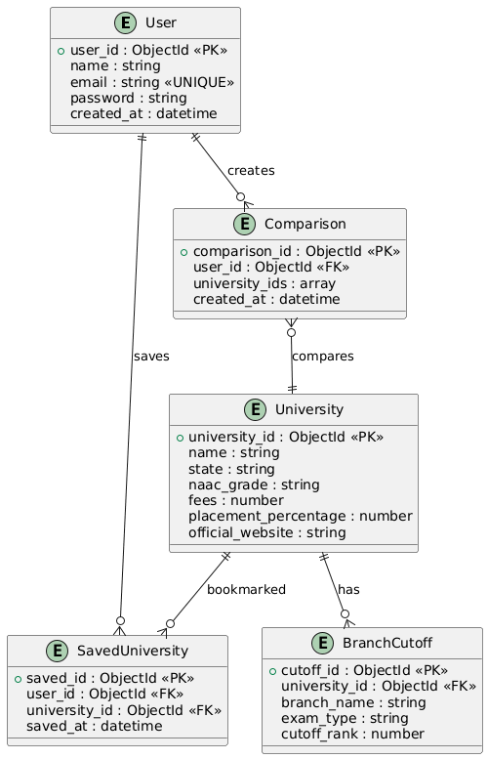

UML DIAGRAMS

CLASS DIAGRAM

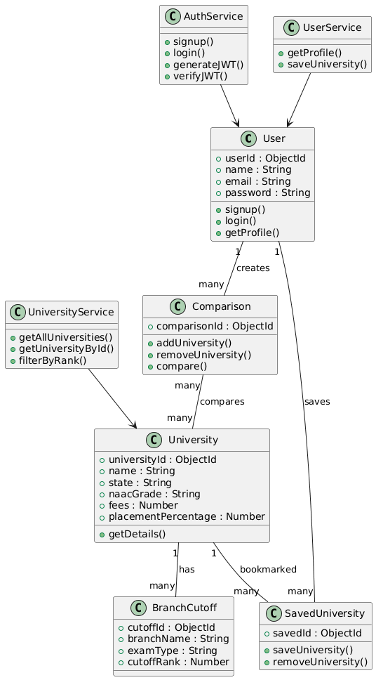

USECASE DIAGRAM
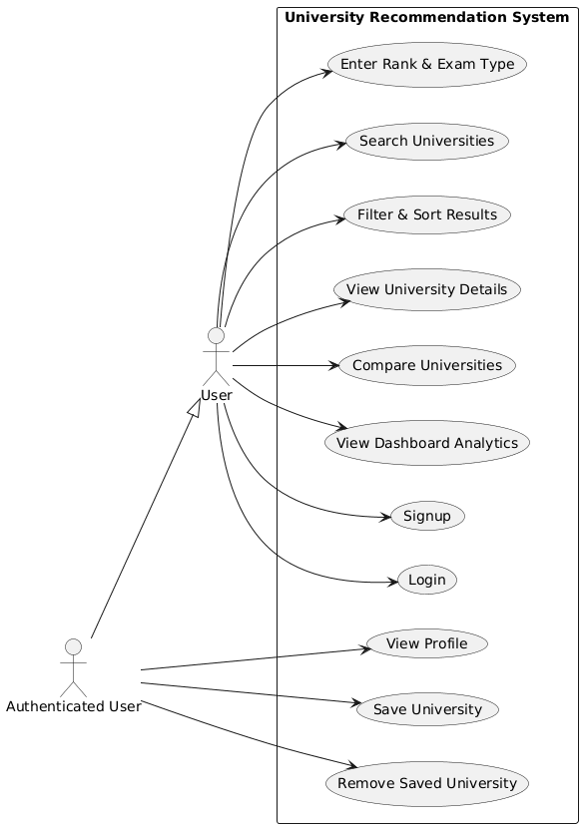

Sequence diagram
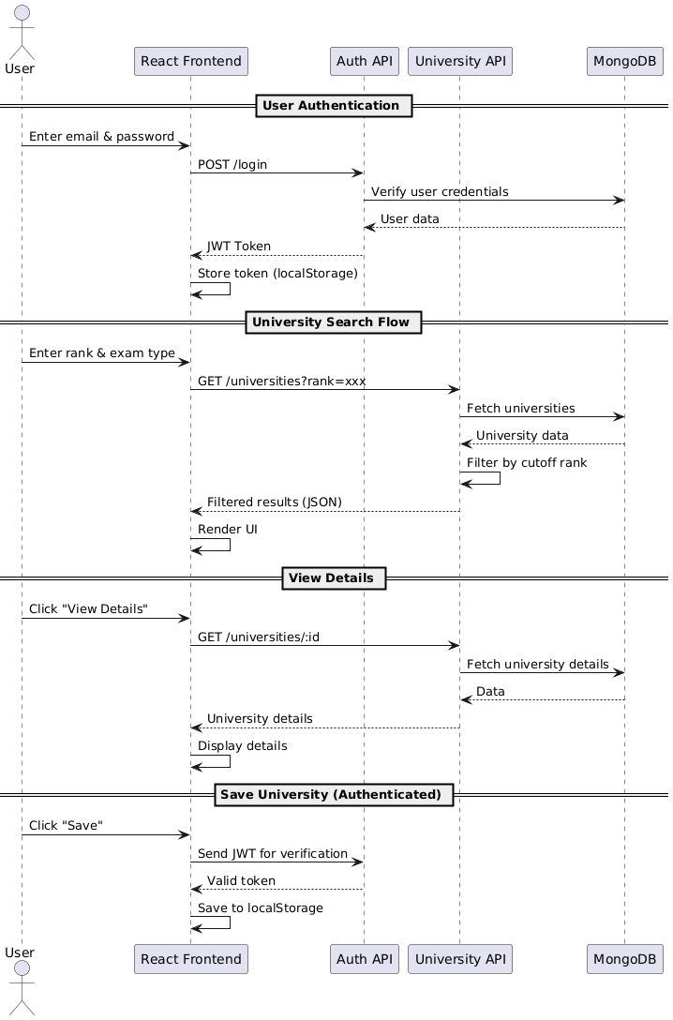Activity diagram

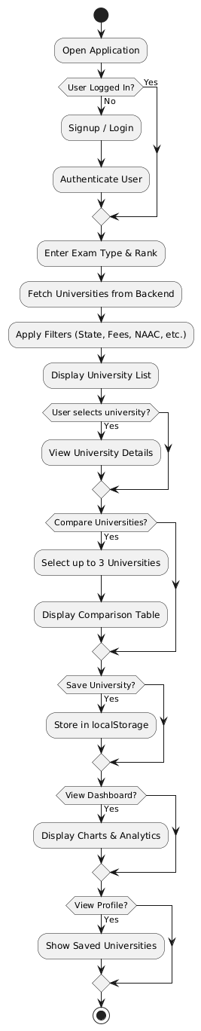

State chart diagram
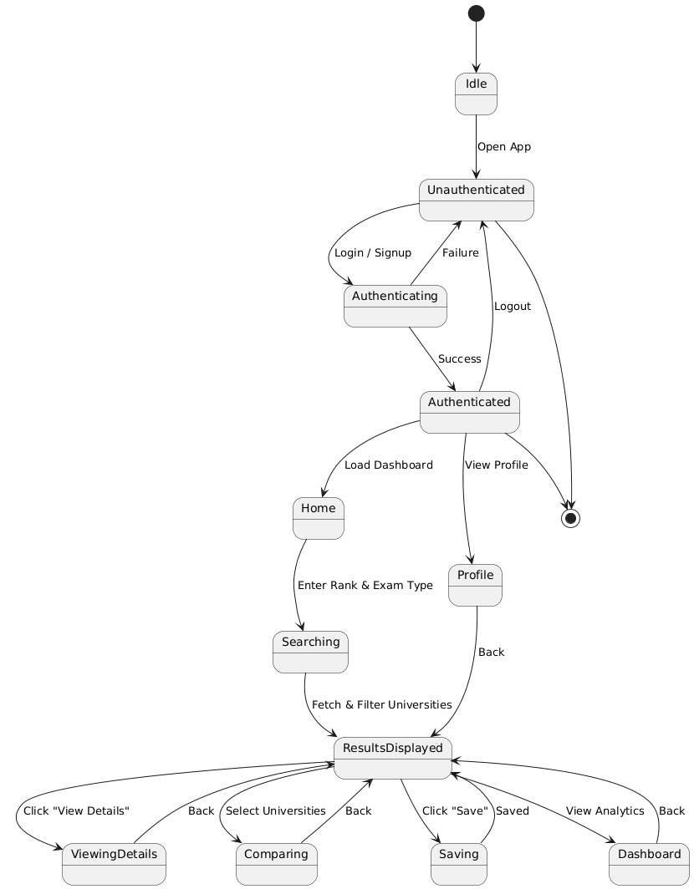

Object diagram
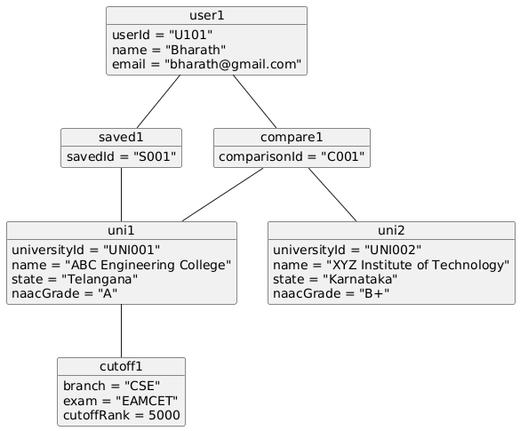

Collaboration diagram
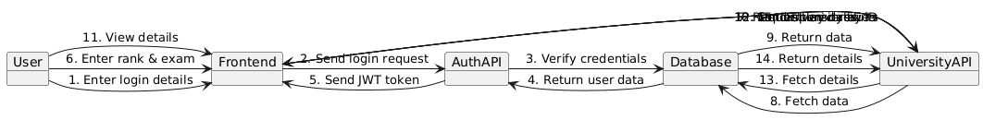

Component diagram
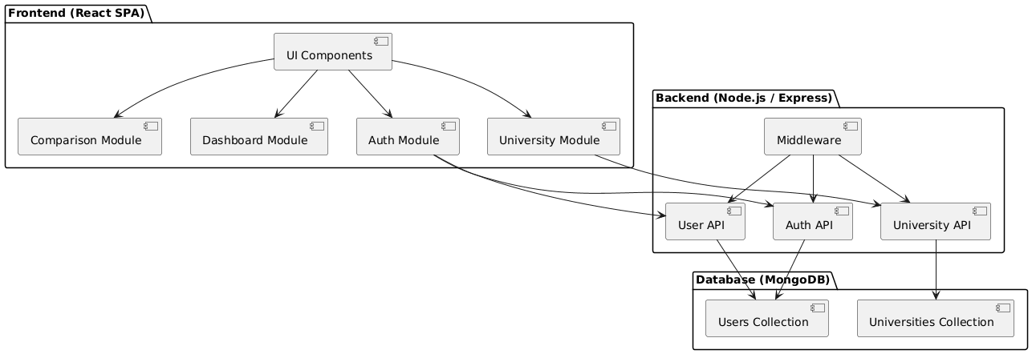

Deployment diagram
